CS 148a Project 5 Writeup
This writeup compares the finalized Project 2, Project 3, and Project 4 checkpoints using the bonus-assignment plots: error vs. sample count, parameter count, and inference wall clock, plus one additional plot based on the ViT tuning sweep.

Methodology
Canonical artifacts used:
- Project 2 reported accuracy source: `../Project 2/CS 148a Project 2 Writeup.pdf`
- Project 3 reported accuracy source: `../Project 3/CS 148a Project 3 Writeup.pdf`
- Project 2 submitted checkpoint for params/timing: osanan/ee148a-project `pipeline-cnn.pt`
- Project 3 submitted checkpoint for params/timing: osanan/ee148a-project `pipeline-vit.pt`
- Project 4 metrics: extracted from the executed notebook `../Project 4/CS148a_proj4_FM_starter.ipynb`
- Additional Project 3 tuning data: `../Project 3/tuning_results.json`
Dataset and split: `MNIST-in-the-world` from Hugging Face, 10,294 total images, 8,749 train and 1,545 validation examples using a fixed seed-42 85/15 split.
Compute resource for wall-clock measurements: Apple M3 Max. This environment did not expose CUDA, so all wall-clock values in this writeup are CPU-side measurements.
Accuracy sourcing policy: Project 2 and Project 3 accuracy values are taken from the submitted writeup PDFs, because those are the reported course-submission numbers. Their exported Hugging Face pipelines are used only for parameter counting and local timing.
Caveats: zero-shot methods have no meaningful downstream sample count, so they are excluded from the sample-count plot; Qwen accuracy in Project 4 was only reported on 256 validation images; the Project 3 notebook describes an additional 60K-image MNIST pretraining phase, but the sample-count axis here only tracks downstream labeled samples on the target dataset.
Timing notes:
- Fusion wall-clock is approximated as CLIP downstream time plus DINO downstream time on CPU.

Compiled metrics
Model | Params | Train samples | Train acc | Val acc | Sec/image | Notes
CNN | 625,610 | 8,749 | n/a | 87.12% | 0.0014 | Accuracy sourced from Project 2 writeup PDF (best validation accuracy 87.1197%);...
ViT | 4,411,722 | 8,749 | 96.93% | 96.25% | 0.0050 | Accuracy sourced from Project 3 writeup PDF (train no-aug 96.93%, val 96.25%); params/timing...
CLIP zero-shot | 427,944,193 | n/a | n/a | 54.82% | 0.1975 | Project 4 notebook output; full 1545-image validation split.
CLIP downstream | 429,263,115 | 17,498 | n/a | 81.04% | 0.1971 | Project 4 notebook output; CLIP encoder plus learned MLP head.
DINO downstream | 307,133,194 | 17,498 | n/a | 68.09% | 0.0818 | Project 4 notebook output; DINOv2 encoder plus learned MLP head.
CLIP + DINO fusion | 736,258,571 | 17,498 | n/a | 82.85% | 0.2788 | Project 4 notebook output; concatenated CLIP and DINO features with fusion head.
Qwen2.5-VL zero-shot | 3,754,622,976 | n/a | n/a | 31.64% | n/a | Project 4 notebook output; accuracy reported on 256 validation images, not the full 1545.

Summary observations
The strongest validation result in this comparison is ViT at 96.25% validation accuracy.
The smallest exported submitted model is CNN with 625,610 parameters.
The fastest measured inference path is CNN at 0.0014 seconds per image on CPU.
Parameter scaling is not monotonic: much larger foundation models do not automatically win on this dataset unless their representations are paired with a strong downstream classifier. The biggest gain in Project 4 comes from moving from CLIP zero-shot to CLIP plus a learned head, which cuts validation error substantially without changing the frozen backbone.
The submitted ViT remains the strongest fully supervised exported checkpoint in the set, but that result depends on more training sophistication than the simple sample-count axis captures: stronger augmentation, a hybrid tokenizer, and an extra clean-MNIST pretraining stage.

Figures
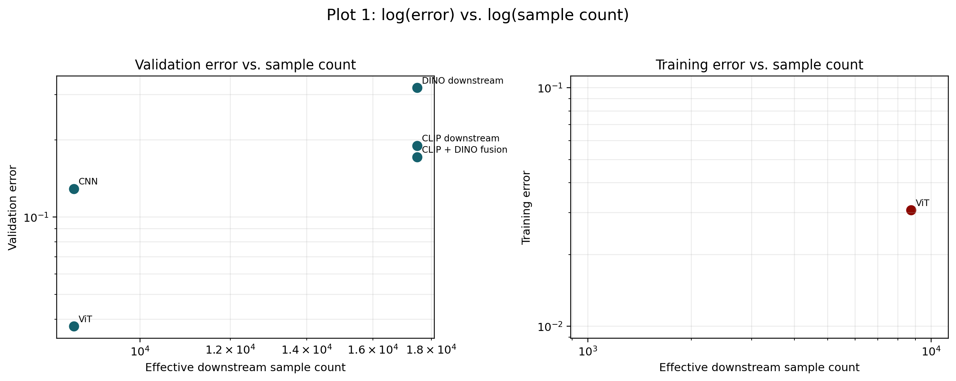
Figure 1. Required Plot 1. Validation and training error against effective downstream sample count. Zero-shot models are excluded because log(0) is undefined.
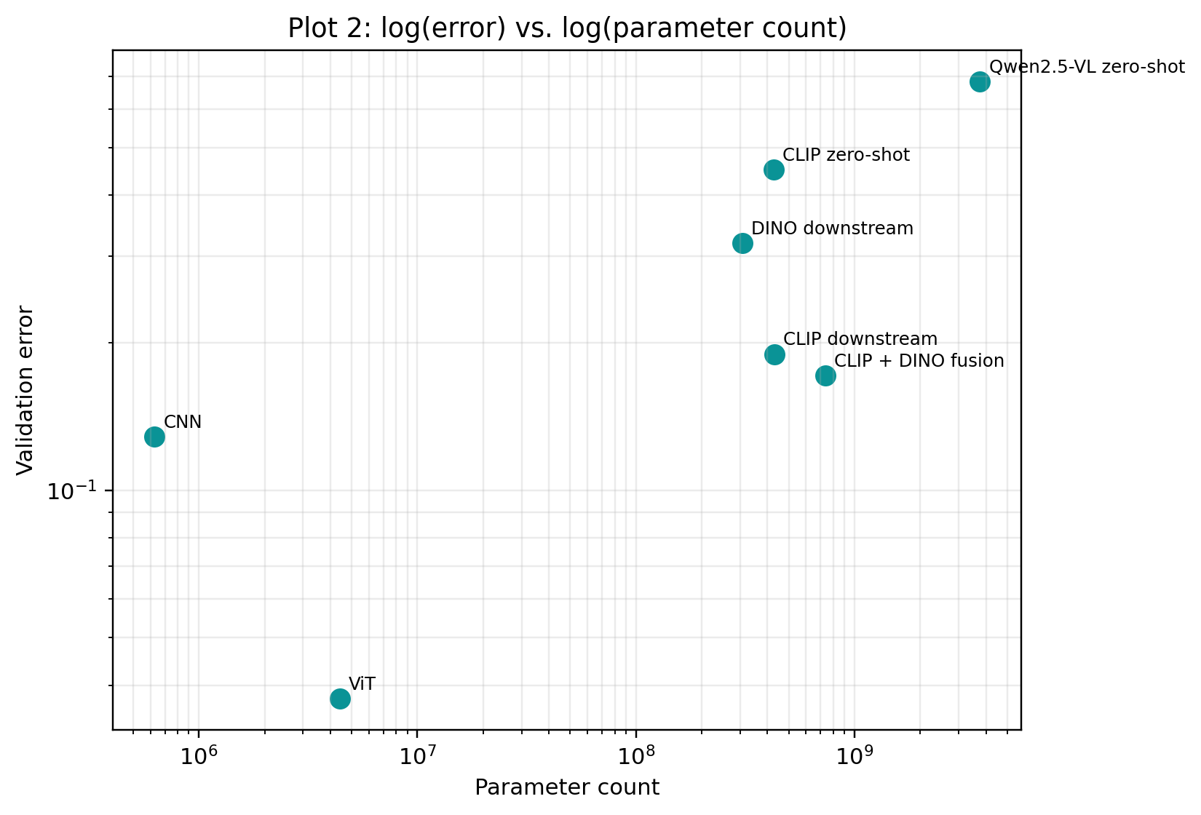
Figure 2. Required Plot 2. Validation error against parameter count across the submitted CNN, submitted ViT, and Project 4 foundation-model variants.
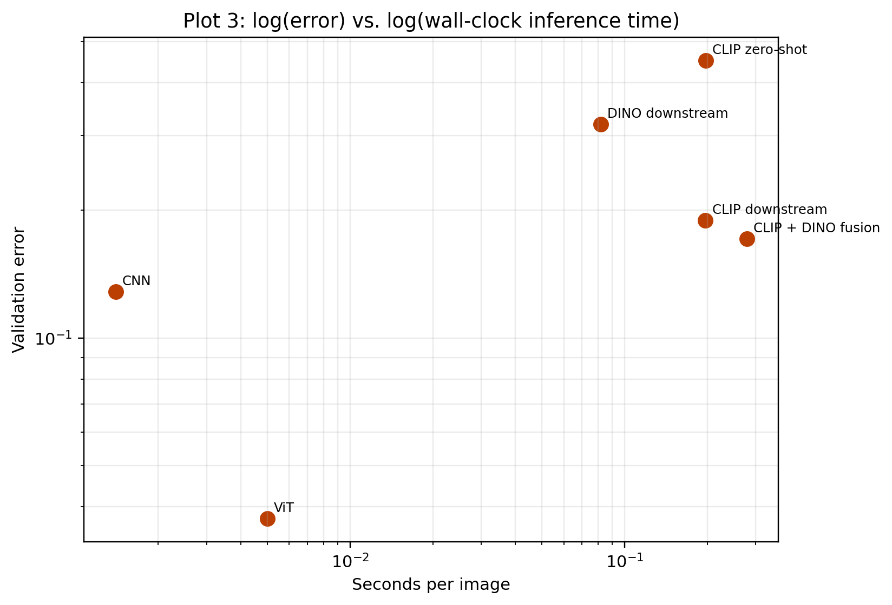
Figure 3. Required Plot 3. Validation error against measured CPU inference time per image. Qwen is omitted from this plot because no comparable CPU timing run was performed in this environment.
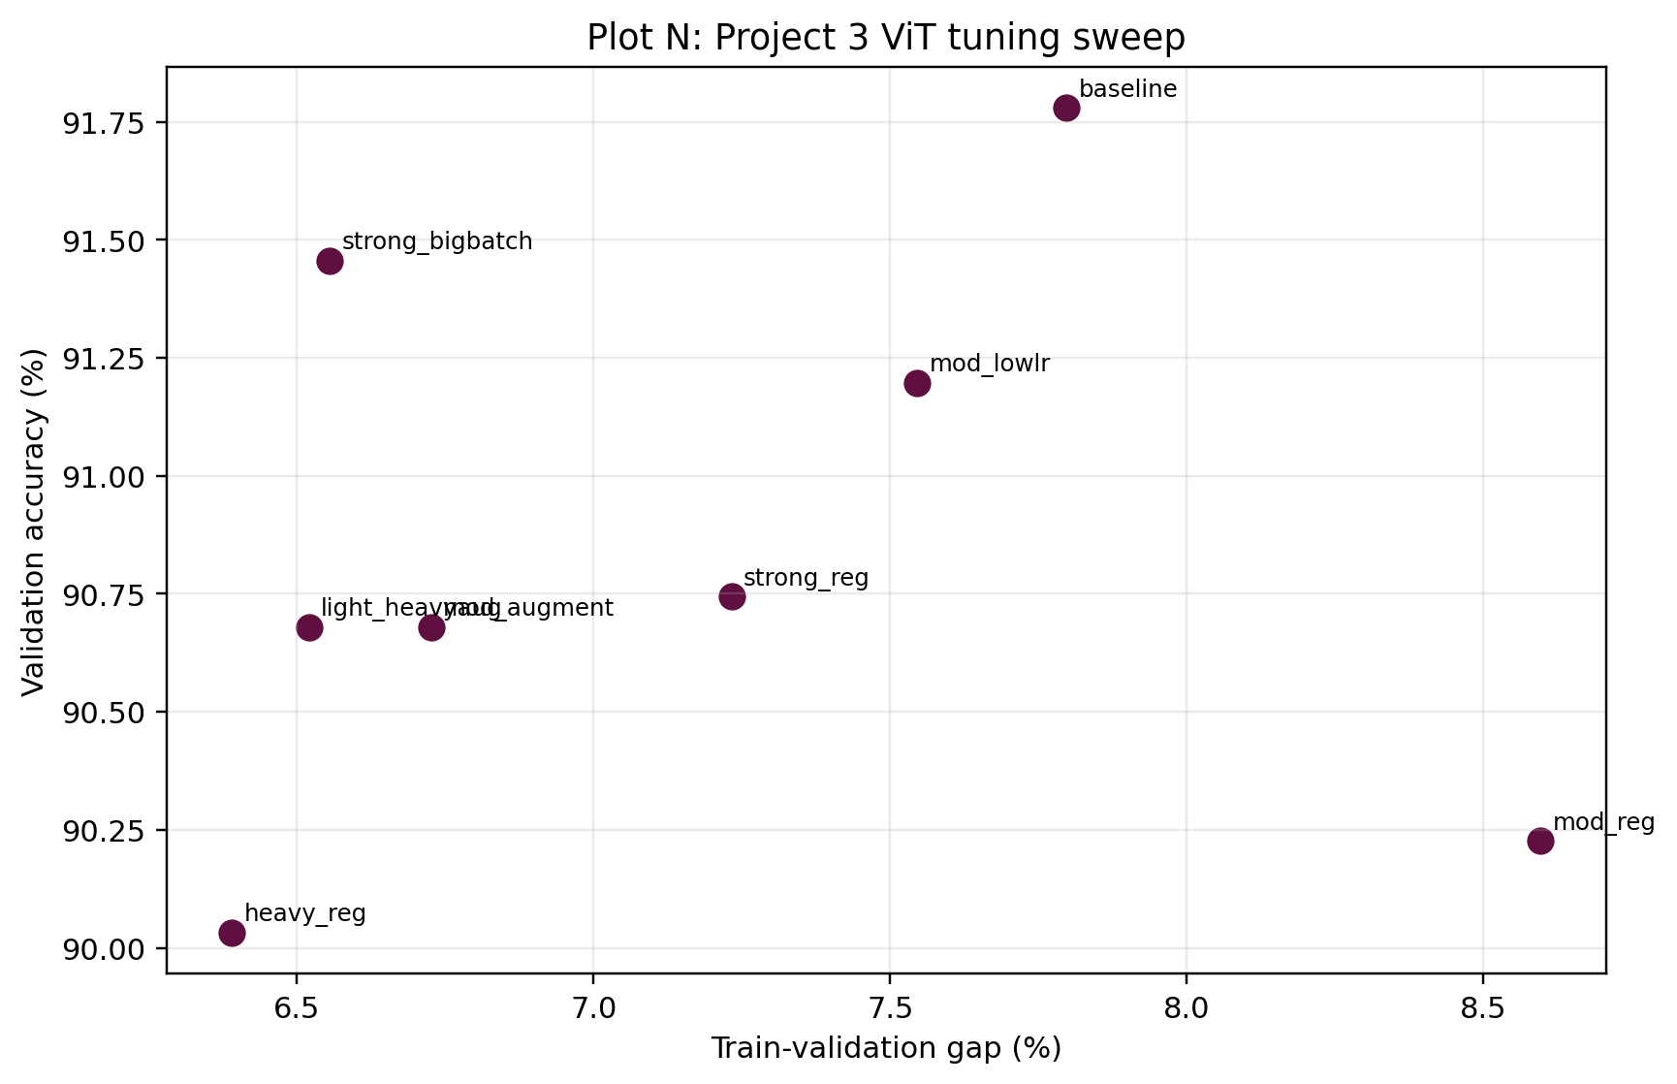
Figure 4. Additional plot. Project 3 ViT tuning sweep showing that a smaller train-validation gap did not always produce the best validation accuracy.

Code / artifact links
Relevant local files for upload/linking:
- ./bonus_analysis.py
- ./bonus_outputs/compiled_metrics.csv
- ../Project 2/CS148a_proj2_CNN_starter.ipynb and ../Project 2/CS148a_proj2_CNN_starter_resnet.ipynb
- ../Project 3/CS148a_proj3_ViT_starter_completed.ipynb
- ../Project 4/CS148a_proj4_FM_starter.ipynb
- Hugging Face submitted model repo: https://huggingface.co/osanan/ee148a-project

AI usage
This analysis and draft writeup were prepared with OpenAI Codex assistance in the local workspace. Per the assignment instructions, the relevant conversation log should be attached or copied into the final submission materials.

